Bug_01:
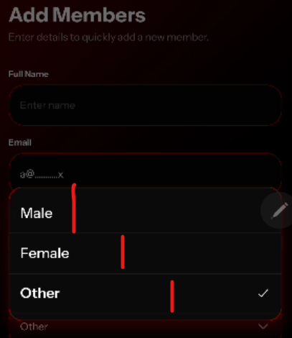
Fields size Consistency issue

Bug_02:
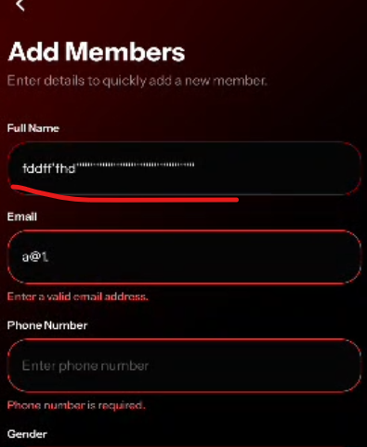
No error message on ‘’’’’’’’’’’’’’’’’

Bug_03:
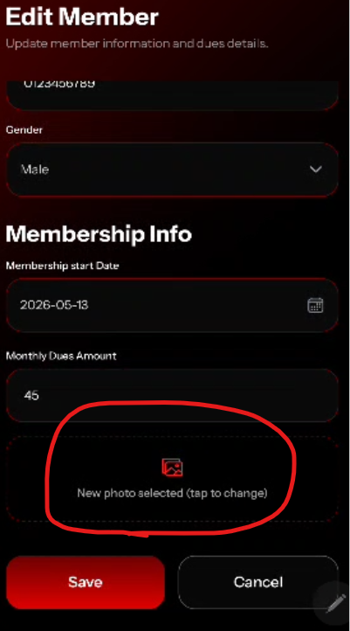
This should not be visible when user can edit image from top

Bug_04:
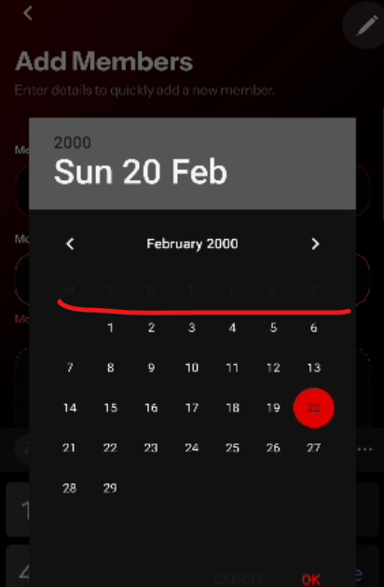
On calendar, days are not visible clearly

